# Creating Histograms

**MS Excel 2007**

## To set up Microsoft Excel for creating histograms

1. Open Microsoft Excel.
2. Click the **Microsoft Office Button** , and then click **Excel Options**.



1. Click **Add-Ins**, and then in the **Manage** box, select **Excel Add-ins**.
2. Click **Go**.
3. In the **Add-Ins available** box, select the **Analysis ToolPak** check box, and then click **OK**.  
   **Tip**: If **Analysis ToolPak** is not listed in the **Add-Ins available** box, click **Browse** to locate it.  
   If you get prompted that the Analysis ToolPak is not currently installed on your computer, click **Yes** to install it.
4. After you load the Analysis ToolPak, the **Data Analysis** command is available in the **Analysis** group on the **Data** tab.

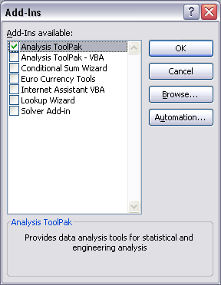

**Making Histograms**

1. Type in the input values to be graphed   
   In the example pictured on the next page, scores for 25 students on a Math test marked out of 50 are given.
2. Choose the boundary values for the "bins" in ascending order (optional).  
   This example shows a set of bin values from 13 (slightly higher than the lowest score) to 49 (just below the highest score). Values will be included in a bin if it is equal to or less than that bin, but greater than all smaller bins. If you don’t set a bin range, it will be calculated for you.
3. Access the Histogram option through the **Data** tab . Click on **Data Analysis** and then choose **Histogram** from the list in the dialog window.  
   You will have to ensure that the **Analysis ToolPak** has been activated (see information above).

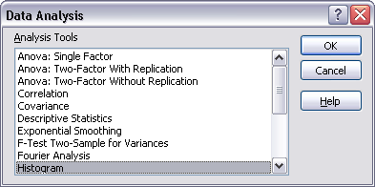

1. Choose the options for your histogram:  
   **Input Range:** Highlight all the cells containing the information for the histogram (cells A6 to A30 in the example).  
   **Bin Range:** Highlight the cells containing the bin range you have planned (cells E10 to E19).   
   **Output Range:** choose at least one cell for your calculated information to be placed, if you are putting it on the same sheet as the input data.  
   **New Worksheet Ply:** Put the information on a new worksheet created for it, within the same workbook.  
   **New Workbook:** Make an entirely new workbook for your calculated information.  
   **Pareto (sorted histogram):** This sorts the data in the output in descending order of frequency. If it is not checked, the data will be sorted in ascending order.  
   **Cumulative Percentage:** Check this to have cumulative percentages calculated and included in the data and histogram.   
   **Chart Output:** Check this to create the data table and the embedded histogram together.

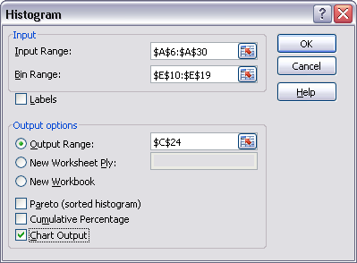

**Sample Data and Histogram:**

