Mathematics 8: Focus on Understanding

Get Ready

Page 385

Proportions within Relationships

a) 4:8 = 5: □

b) 9:3 = □:10

c) □:2 = 8:32

d) 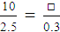

e) 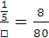

f) 