
Math Essentials 11

Section 1.2 Question 5

1. Select all of the data below the title and use the “Edit” menu to locate the “Replace” tool.

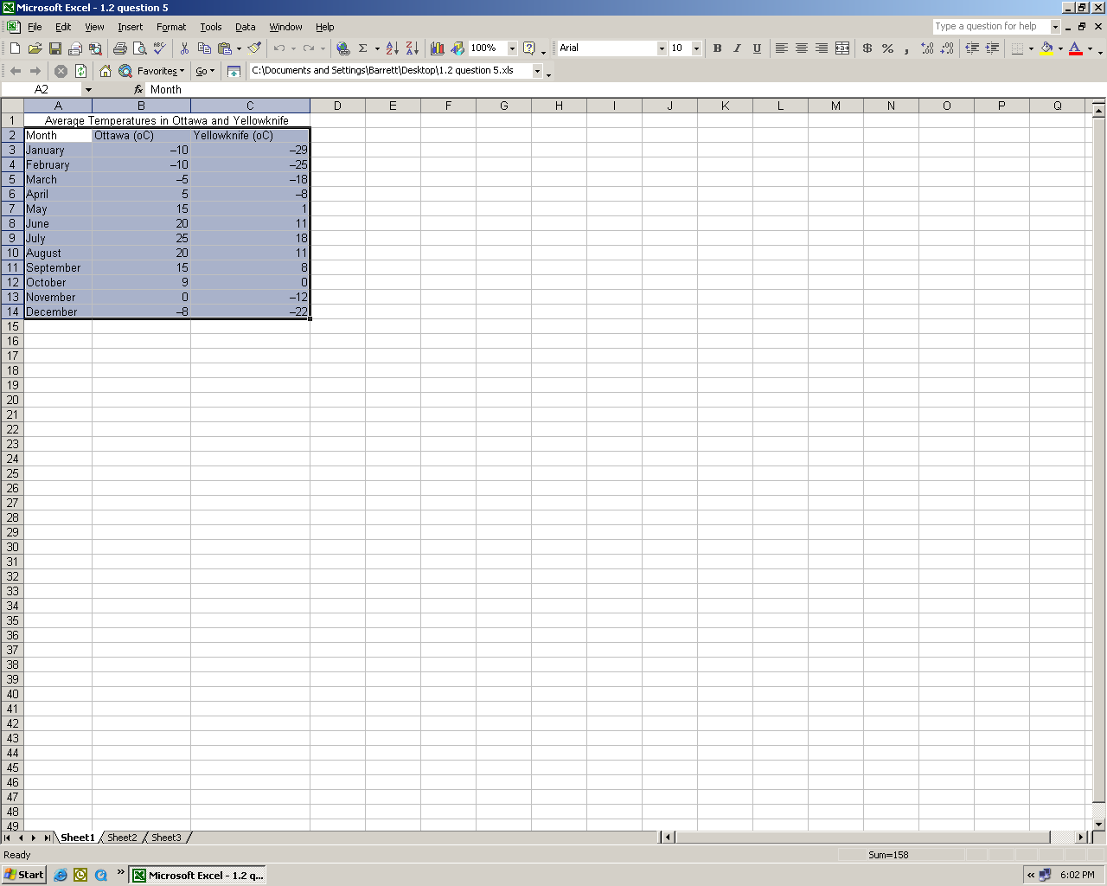

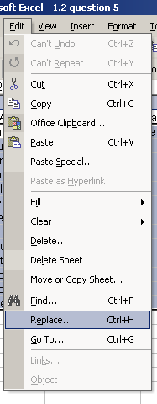
a. Paste the dash (the symbol in front of the negative temperature) in the “Find what” field.
“Replace”
“Edit”

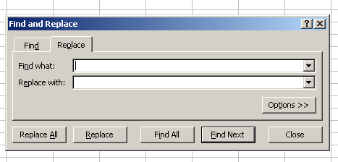
b. Type the subtraction symbol.

2. Select the data in your table once again and select the “Chart” Wizard.

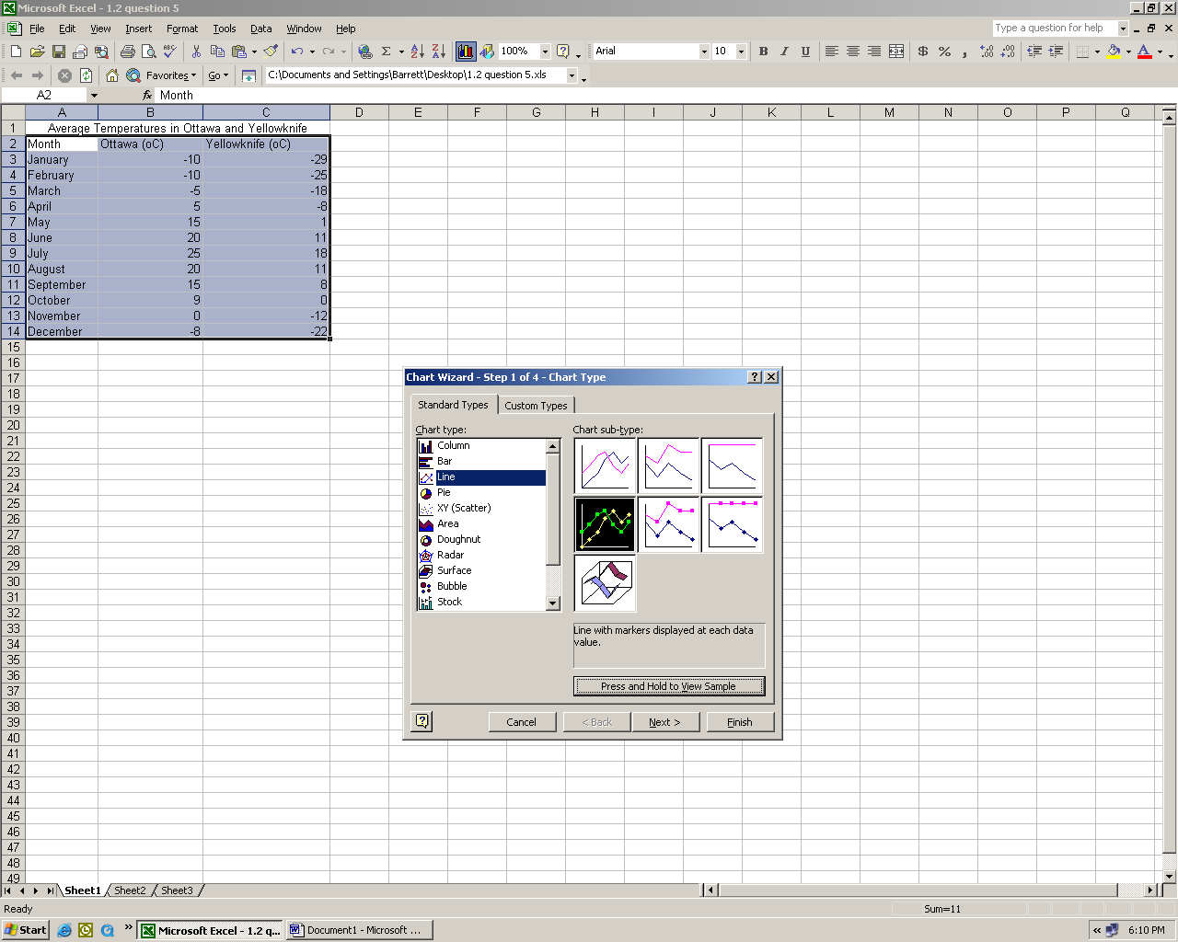

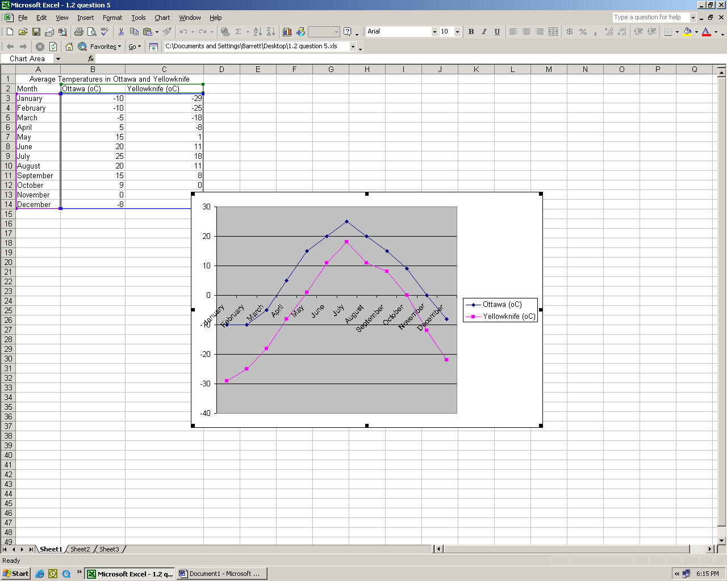
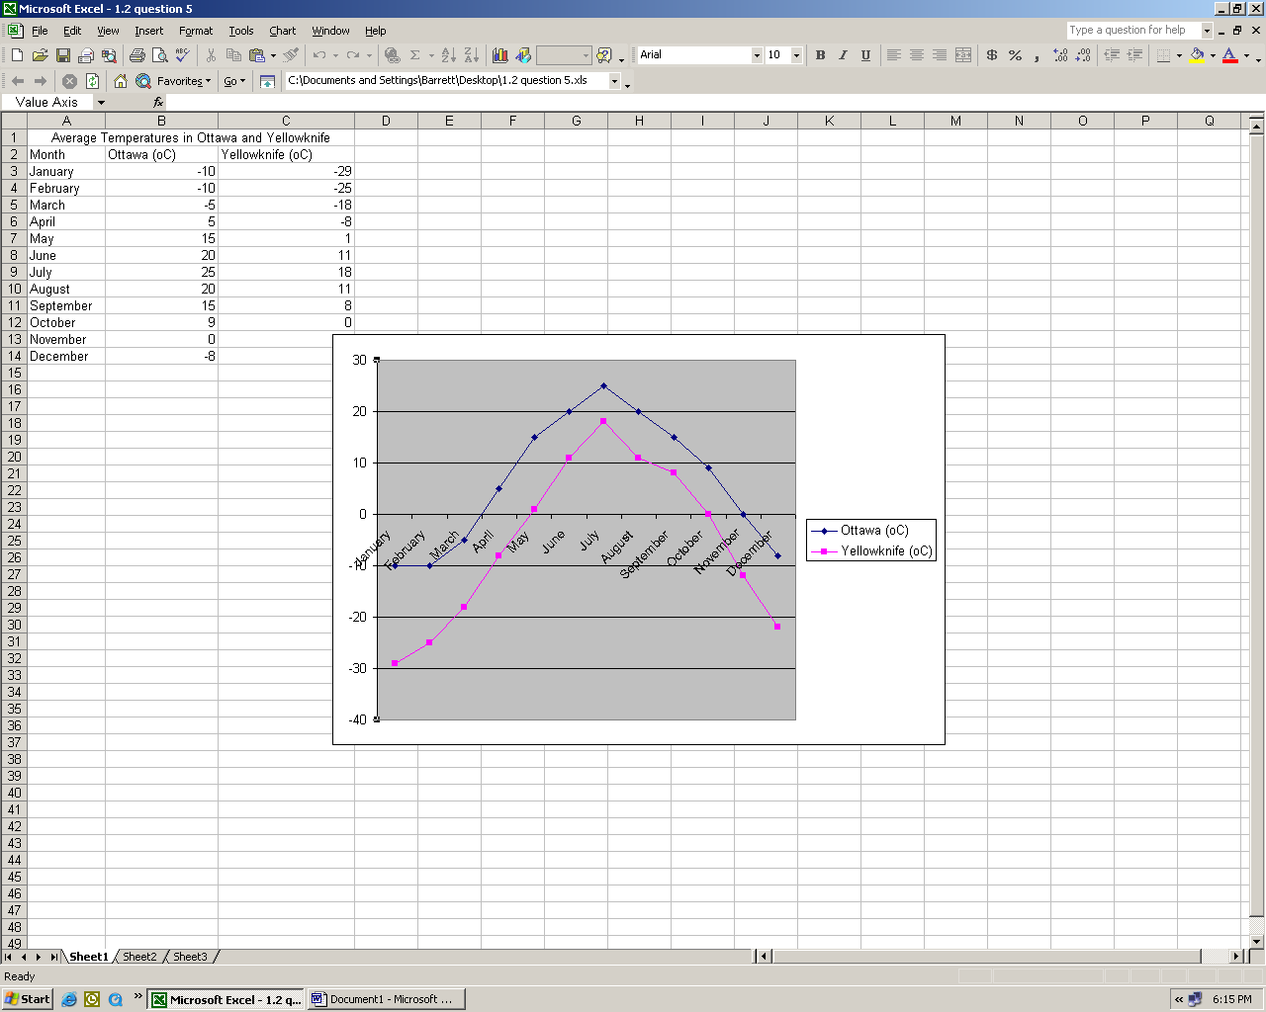
Select the Y axis and right click the mouse

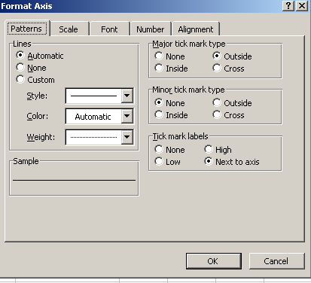
“Scale”

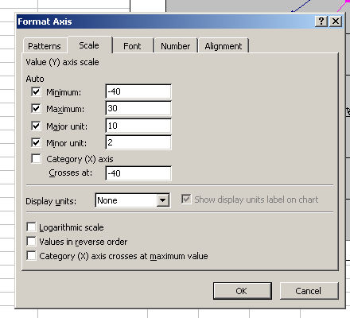
Change “Category (X) axis Crosses at” to -40

Select the entire line graph, right click and select “Chart Options” to enter the title and axis labels.



