Trigonometric Functions

The graph of a trigonometric function such as y = sinx or y = cosx is a smooth curve. The graph of y = sinx where x is an angle such that 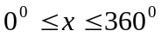and y is the sine of each angle, can be drawn by plotting the following points:

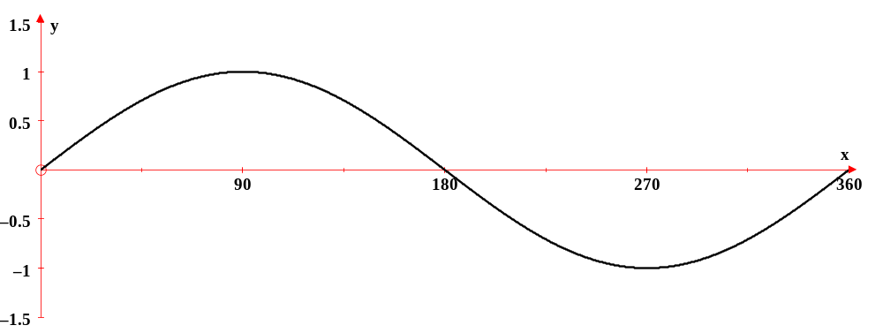

The graph of y = sinx can also be reflected in the x-axis. This will create a graph in which the above y-values take on opposite signs. The equation would be written as
-y = sinx. and the table of values would be as follows:

The reflection of y = sinx is shown below:
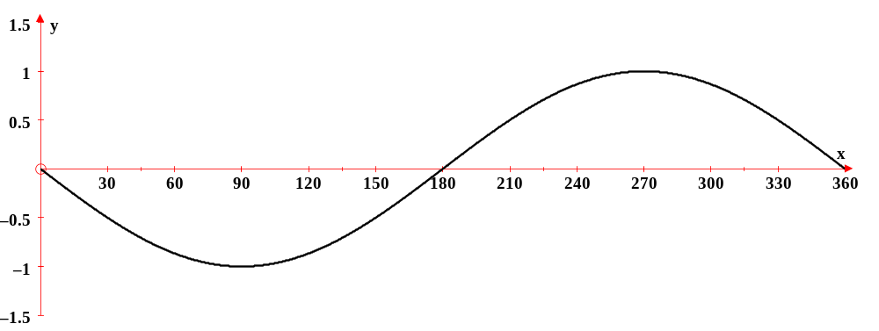

Using the points from the table, allow the students to see the formation of the curve as the points are connected. These points represent one cycle of the function. Once the students are familiar with the shape of the curve, they can reduce the number of points to the five critical values that are used to draw the graph of y = sinx. These five critical values or points are:

X | 0⁰ | 90⁰ | 180⁰ | 270⁰ | 360⁰
Y | 0 | 1 | 0 | -1 | 0

Students should now examine the graph to note its characteristics. The graph has a maximum value of 1 at x = 90⁰ and a minimum value of -1 at x = 270⁰. The graph also has three points plotted on the line y = 0 at x = 0⁰ , x = 180⁰ and at x = 360⁰.
This line, y = 0, is located midway between the maximum and minimum values.
The name given to this line is the sinusoidal axis.

The distance from the sinusoidal axis to either the maximum value or to the minimum value is called the amplitude of the curve.

To graph one cycle of the sine curve requires 360⁰. This represents the period of the sine curve.

The first point that was plotted was (0⁰, 0). If the beginning point moves to the left or right of 0⁰, the amount of movement is known as the phase shift.
The graph of y = sinx will repeat every 360⁰ and is therefore periodic. This can be seen in the graph below as one cycle appears from 0⁰ to -360⁰ and another from 0⁰ to 360⁰.

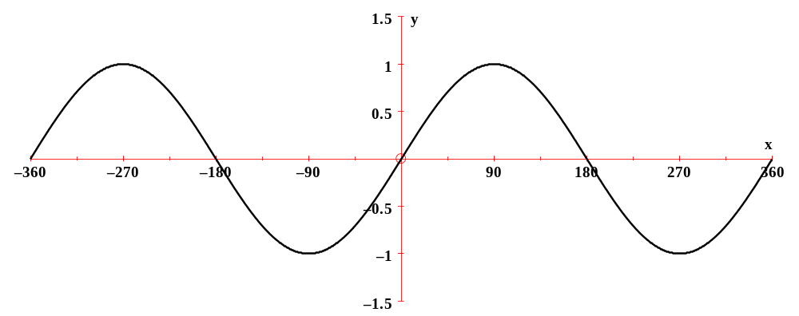

The graph of y = sinx can undergo transformations that will directly affect the characteristics of the graph. If the graph is moved 30⁰ to the left, it undergoes a horizontal translation that will produce a phase shift of -30⁰. This transformation is shown in the equation as y = sin(x + 30⁰) and in the graph below:

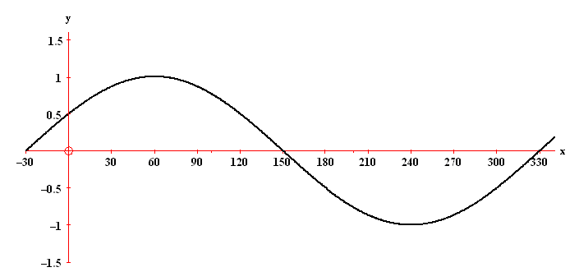

Notice that every aspect of the curve of y = sinx remained unchanged except for the x-values. The first point is (-30,0) and NOT (0.0). As a result, each of the x-values of the critical points followed suit and are all 30⁰ to the left of the original value.

The table of values for y = sinx is:

X | 0⁰ | 90⁰ | 180⁰ | 270⁰ | 360⁰
Y | 0 | 1 | 0 | -1 | 0

The table of values for y = sin(x + 30⁰) is:

X | -30⁰ | 60⁰ | 150⁰ | 240⁰ | 330⁰
Y | 0 | 1 | 0 | -1 | 0

Another transformation that can be applied to y = sinx is a vertical translation. A vertical translation of -2 will move the sinusoidal axis to y = -2 and in turn the entire graph will be moved downward two units. This change is shown in the equation as (y + 2) = sinx.
This transformation is shown in the next graph:

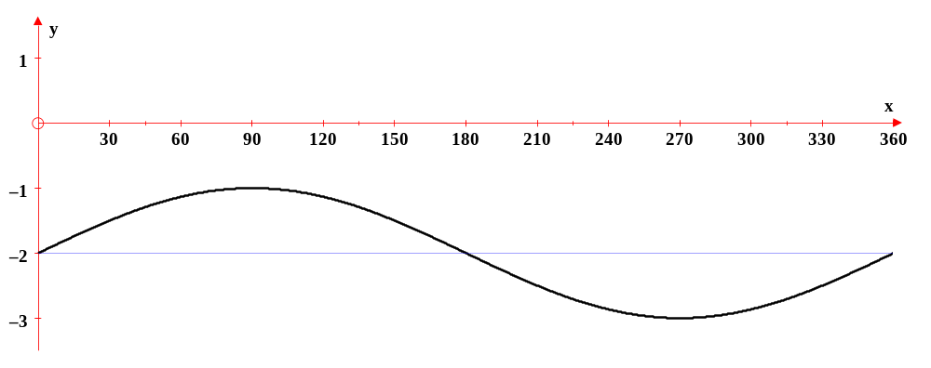

Notice how the entire graph has moved downward. The blue line, which is located midway between the maximum value of -1 and the minimum value of -3, is the sinusoidal axis and its equation is y = -2. The only difference between the table of values for the graph of y = sinx and the tale of values for the graph of (y + 2) = sinx is that the y-values of 0 in the initial table are now -2, thus causing the maximum value to be -1 and the minimum value to be -3.

The table of values for y = sinx is:

X | 0⁰ | 90⁰ | 180⁰ | 270⁰ | 360⁰
Y | 0 | 1 | 0 | -1 | 0

The table of values for (y + 2) = sinx is:

X | 0⁰ | 90⁰ | 180⁰ | 270⁰ | 360⁰
Y | -2 | -1 | -2 | -3 | -2

All of the graphs that have been plotted thus far have an amplitude of one. By applying a
vertical stretch to the graph of y = sinx, the amplitude can be increased or decreased.
A vertical stretch is shown in the equation as y = sinx. This will produce a graph that will have an amplitude of 2. This means that the distance from the sinusoidal axis to either the maximum value or the minimum value will be 2. A vertical stretch of is shown in the equation as 2y = sinx. This will produce a graph that has an amplitude of and the distance from the sinusoidal axis to either the maximum value or the minimum value will be. The graphs below will show these transformations respectively:

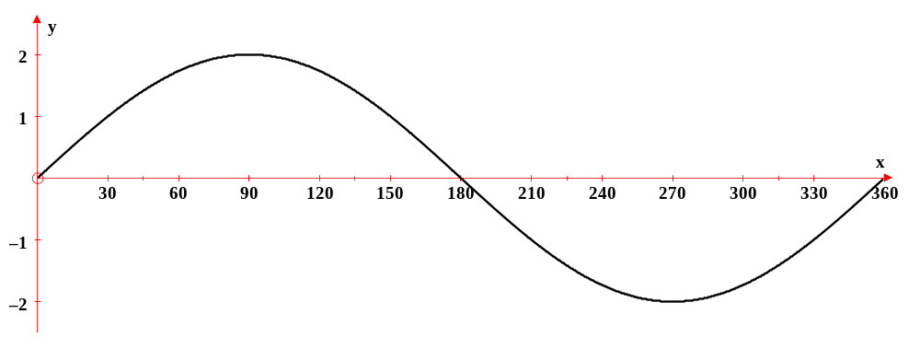
When the table of values of y = sinx is compared to the table of values of y = sinx, the only difference is the y-values of the maximum and minimum points are now 2 and -2

respectively.

The table of values for y = sinx is:

X | 0⁰ | 90⁰ | 180⁰ | 270⁰ | 360⁰
Y | 0 | 1 | 0 | -1 | 0

The table of values for y = sinx is:

X | 0⁰ | 90⁰ | 180⁰ | 270⁰ | 360⁰
Y | 0 | 2 | 0 | -2 | 0

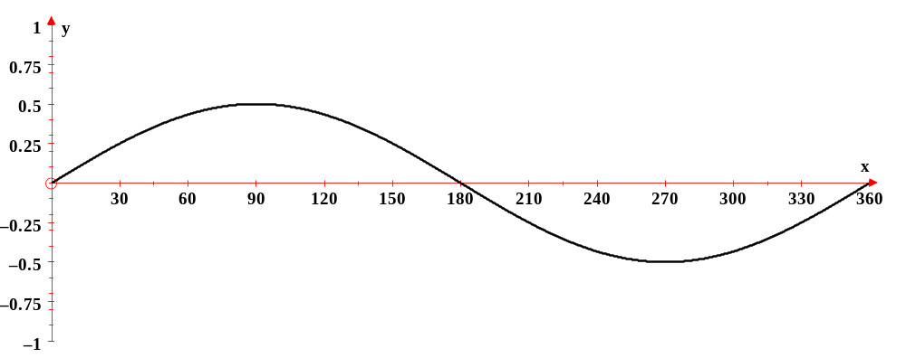

When the table of values of y = sinx is compared to the table of values of 2y = sinx, the only difference is the y-values of the maximum and minimum points are now and 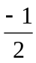 respectively.

The table of values for y = sinx is:

X | 0⁰ | 90⁰ | 180⁰ | 270⁰ | 360⁰
Y | 0 | 1 | 0 | -1 | 0

The table of values for 2y = sinx is:

X | 0⁰ | 90⁰ | 180⁰ | 270⁰ | 360⁰
Y | 0 | 1  2 | 0 | -1  2 | 0

The period or the domain over which one cycle of the curve is drawn is 360⁰. However, the curve can undergo a horizontal stretch which will produce an increase or a decrease in the period. A horizontal stretch of 2 will produce one cycle of the graph of y = sinx that is plotted over a domain of 720⁰.
This transformation is written in the equation as y = sinx.
On the other hand, a horizontal stretch of will produce one cycle of the graph of y = sinx that is plotted over a domain of 180⁰. This transformation is written in the
equation as y = sin2x. The next graphs will show these transformations respectively:
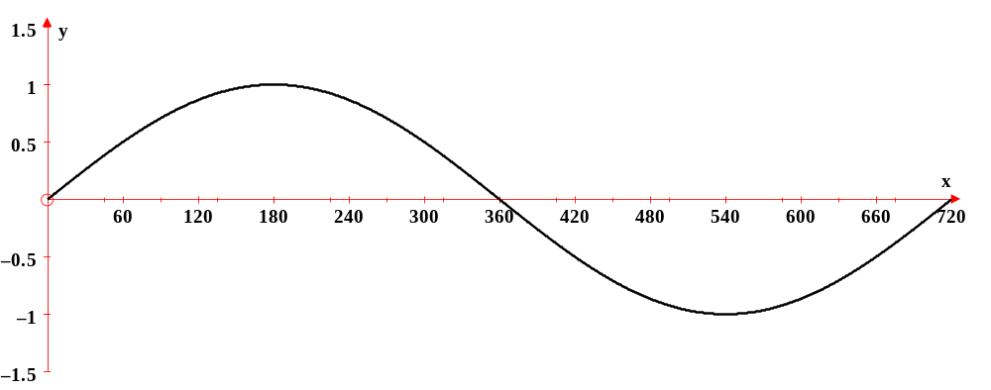

The stretch of the curve can be seen quite clearly. One cycle of the curve is drawn such that 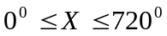. Therefore the x-values in the table of values for y = sinx will all be doubled in the table of values for y = sinx.

The table of values for y = sinx:

X | 0⁰ | 90⁰ | 180⁰ | 270⁰ | 360⁰
Y | 0 | 1 | 0 | -1 | 0

The table of values for y = sinx is:

X | 0⁰ | 180⁰ | 360⁰ | 540⁰ | 720⁰
Y | 0 | 1 | 0 | -1 | 0

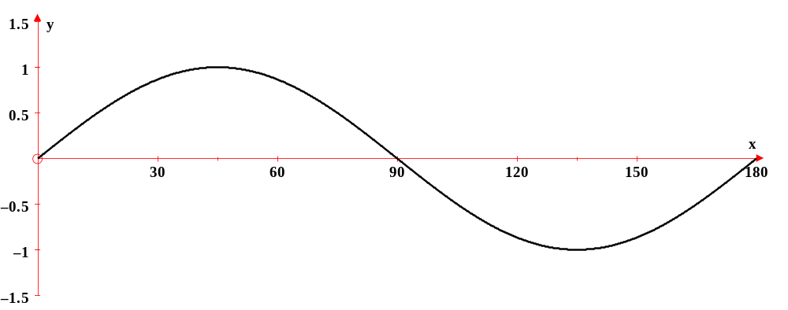
The stretch of the curve can be seen quite clearly. One cycle of the curve is drawn such that 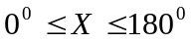. Therefore the x-values in the table of values for y = sinx will all be multiplied by one-half in the table of values for y = sin2x.

The table of values for y = sinx:

X | 0⁰ | 90⁰ | 180⁰ | 270⁰ | 360⁰
Y | 0 | 1 | 0 | -1 | 0

The table of values for y = sin2x is:

X | 0⁰ | 45⁰ | 90⁰ | 135⁰ | 180⁰
Y | 0 | 1 | 0 | -1 | 0

All of the transformations that can be applied to the graph of y = sinx have been shown graphically and as they appear in the equation. The equation of y = sinx that shows the transformations is written in a form called transformational form. Transformational form of the equation y = sinx is written as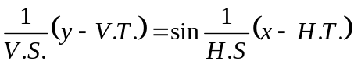. The transformations of y = sinx can be listed from the equation. Not all of the transformations need to be applied to the function at once. There can be as few as one and as many as five transformations applied to the graph of y = sinx.

Example 1: For the following function, list the transformations of y = sinx and use these transformations to draw the graph.

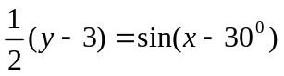

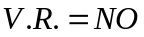
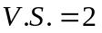
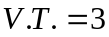
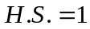
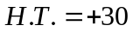

There is no negative sign in front of 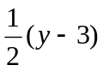so there is no vertical reflection. There is a vertical stretch of 2 which indicates that the amplitude of the curve will be two from the sinusoidal axis of y = 3. The horizontal stretch of 1 means that the graph will extend over 360⁰ with the first x-value being +30⁰. As a result of these transformations, the x-axis will begin at 0⁰ and continue to 390⁰. The y-axis will begin at 0 and extend to +5. The sinusoidal axis will be located at y = 3. The first point of (30⁰, 3) will be plotted and the remaining 4 points will be plotted at 90⁰intervals on the line y = 3. The second point will be moved upward to become (120⁰, 5) and the fourth point will be moved downward to become (300⁰, 1). Following these steps will produce the following graph:

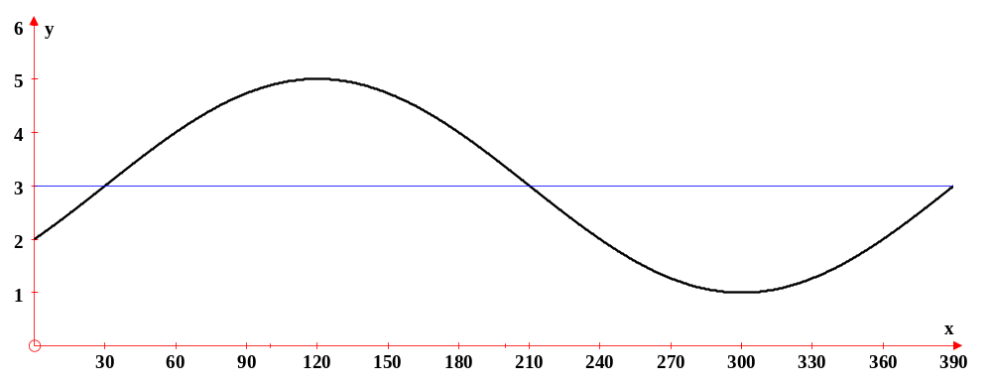

The table of values for y = sinx is:

X | 0⁰ | 90⁰ | 180⁰ | 270⁰ | 360⁰
Y | 0 | 1 | 0 | -1 | 0

The table of values for is:
X | 30⁰ | 120⁰ | 210⁰ | 300⁰ | 390⁰
Y | 3 | 5 | 3 | 1 | 3

Example 2: For the following function, list the transformations of y = sinx and use these transformations to draw the graph.

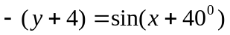
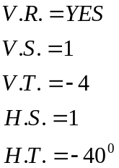

There is a negative sign in front of the expression (y + 4) which indicates that there is a vertical reflection. The curve will have an amplitude of 1 from the sinusoidal axis of y = -4. The curve will be drawn over 360⁰ with the first x-value located at -40⁰. The x-axis will begin at -40⁰ and extend to 320⁰. The y-axis will extend from -5 to +5. The sinusoidal axis will be the line y = -4. The first point of (-40⁰, -4) will be plotted and the remaining 4 points will be plotted at 90⁰intervals on the line y = -4. The second point will be moved downward 1 to become (50⁰, -5) and the fourth point will be moved upward 1 to become (230⁰, -3). Following these steps will result in this graph:
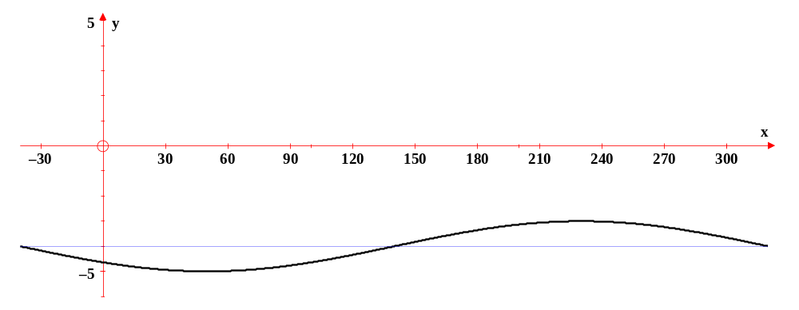

The table of values for y = sinx is:

X | 0⁰ | 90⁰ | 180⁰ | 270⁰ | 360⁰
Y | 0 | 1 | 0 | -1 | 0

The table of values for is:

X | -40⁰ | 50⁰ | 140⁰ | 230⁰ | 320⁰
Y | -4 | -5 | -4 | -3 | -4
Example 3: For the following function, list the transformations of y = sinx and use these transformations to draw the graph.

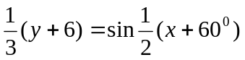

The transformations of y = sinx are:
There is no negative sign in front of the expression 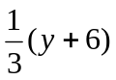so there is NO vertical reflection. The vertical stretch of 3 means that the amplitude of the curve is 3. The vertical translation of -6 means that the sinusoidal axis is located down six and its equation is y = -6. The horizontal stretch of 2 means that the curve will be graphed over 720⁰. The horizontal stretch is a factor that multiplies one period of the curve. The horizontal translation of -60⁰ means that the x-value of the first point (the phase shift) is -60⁰.
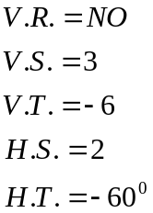

These transformations can now be used to draw the graph. First draw the axes required for the graph by considering both the horizontal and the vertical stretches. The x-axis must extend to 720⁰ since the horizontal stretch is 2 but it must begin at -60⁰ to accommodate the horizontal translation. The y-axis must extend from +3 to -3 since the vertical stretch is 3 but this stretch must be applied to the sinusoidal axis of y = -6. Therefore the y-axis must extend from -3 to -9. However, to show the x-axis, the y-axis must be drawn from 0 to -9. Once the axes have been completed, the line y = -6 should be graphed. This can be done using a broken line since its presence is not necessary for the graph. Now the point (-60⁰,-6) can be plotted. Four other points are needed to complete the graph which must be drawn over 720⁰. To determine the interval between the points, divide 720⁰ by 4. Beginning at -60⁰, add 180⁰ and plot the second point on the line y = -6. Continue this until five points have been plotted. The second and fourth points of the graph produce the maximum and the minimum values of the curve. Move the second point up 3 units from y = -6 and the fourth point down 3 units from y = -6. There are now five points plotted to form the graph of.
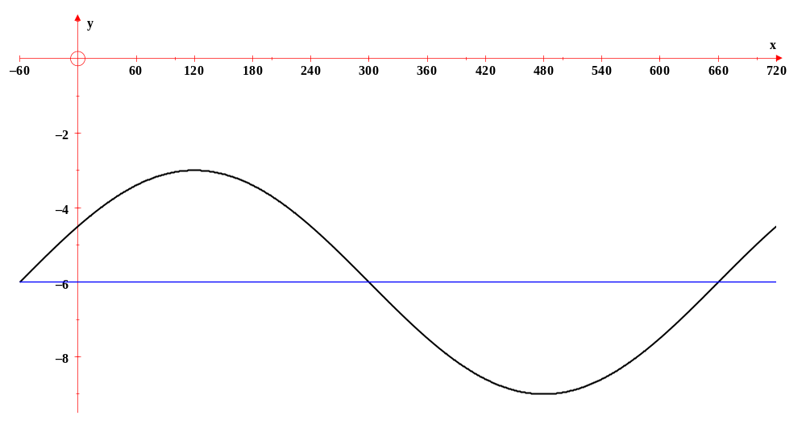

The table of values for y = sinx is:

X | 0⁰ | 90⁰ | 180⁰ | 270⁰ | 360⁰
Y | 0 | 1 | 0 | -1 | 0

The table of values for is:

X | -60⁰ | 120⁰ | 300⁰ | 480⁰ | 660⁰
Y | -6 | -3 | -6 | -9 | -6

Example 4: For the equation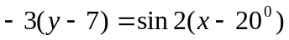, list the transformations of
y = sinx and use these transformations to draw the graph.
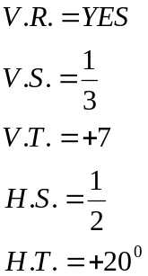

There is a vertical reflection so the graph will go downward first and then curve upward. The vertical stretch will produce a graph that has an amplitude of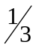. The graph will move up from the x-axis to the line y = 7. The entire graph will be drawn over one-half of 360⁰ with the first x-value being located at 20⁰. If 180⁰ is divided by 4, the interval between the five points is 45⁰. The remaining four points can be plotted on the line y = 7. The second point must be placed downward from y = 7 and the fourth point must be placed upward from the sinusoidal axis. The points can now be joined to form the smooth curve that represents the graph of .
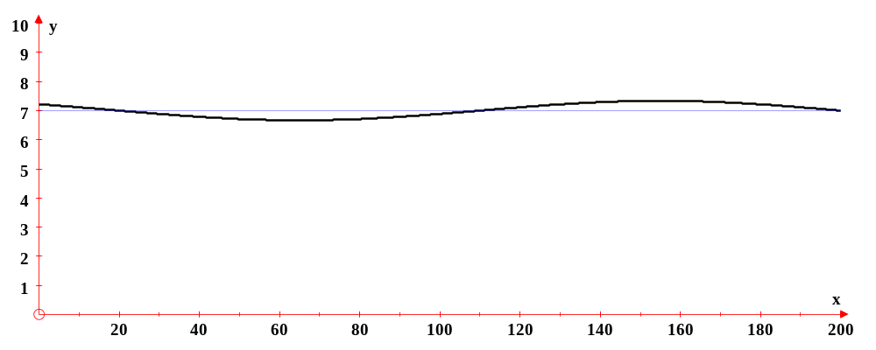

The table of values for y = sinx is:

X | 0⁰ | 90⁰ | 180⁰ | 270⁰ | 360⁰
Y | 0 | 1 | 0 | -1 | 0

The table of values for is:

X | 20⁰ | 65⁰ | 110⁰ | 155⁰ | 200⁰
Y | 7 | 6.67 | 7 | 7.33 | 7

Example 5: For the following function, list the transformations of y = sinx and use these transformations to draw the graph

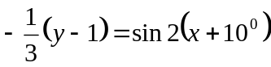

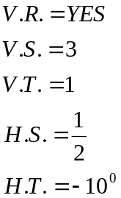

Allow the students to provide the steps necessary to construct the following graph: This will give them an opportunity to exhibit their understanding of sketching the graph by using the transformations of y = sinx

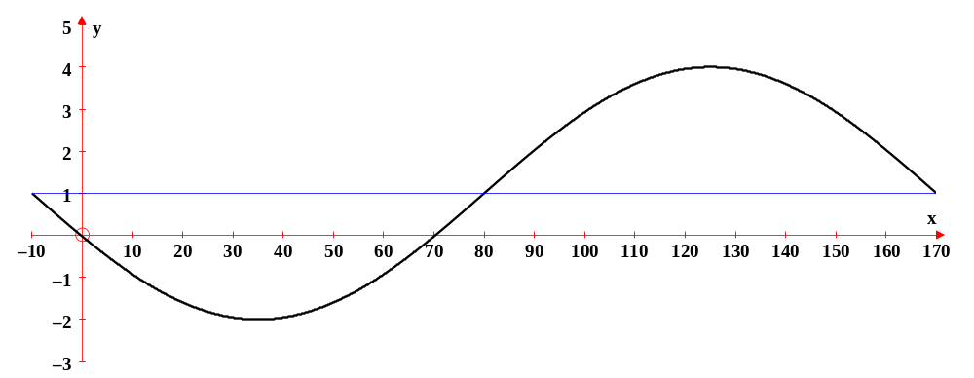

The table of values for y = sinx is:

X | 0⁰ | 90⁰ | 180⁰ | 270⁰ | 360⁰
Y | 0 | 1 | 0 | -1 | 0
The table of values for is:

X | -10⁰ | 35⁰ | 80⁰ | 125⁰ | 170⁰
Y | 1 | -2 | 1 | 4 | 1

All of the graphs presented thus far, have been shown with a white background. However, when students create a graph using pencil and paper, it is best if they use grid paper. This simplifies the plotting of the transformations. Grid paper is also used when students are presented with a graph and asked to list the transformations or to write the equation that models the graph. When analyzing a graph, the grid paper allows the students to see the exact numbers – thus eliminating estimation the values.

Example 1: For the following graph we will list the transformations of y = sinx and
explain how each was determined.
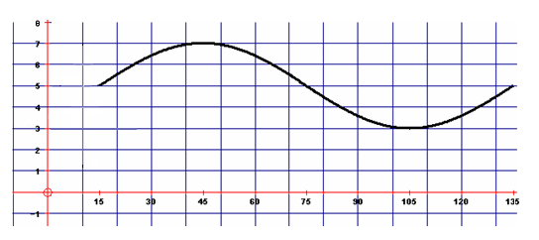

The graph is not a reflection. The graph curves upward first and then downward. The graph has a sinusoidal axis of y = 5 and the distance from the sinusoidal axis to the maximum point is 2. Therefore, it has a vertical stretch of 2. The graph begins at 15⁰ and ends at 135⁰ producing a period of 135⁰- 15⁰ = 120⁰.

This makes the horizontal stretch 120⁰ or 1. The first x-value or phase shift of the
360⁰ 3
graph is 15⁰ which means the horizontal translation is 15⁰.

Transformations of y = sinx: 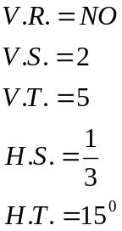

Example 2: For this next graph, we will simply list the transformations of y = sinx because the students should now understand how to determine each change from the graph.

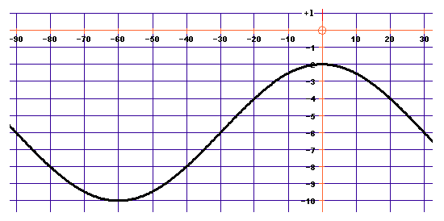

Notice that the sinusoidal axis was not drawn in this graph. The students must learn that the location of the axis is midway between the maximum and minimum points.

The transformations of y = sinx:
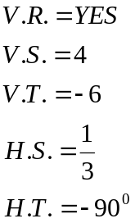

Example 3: For the following graph, list the transformations of y = sinx.

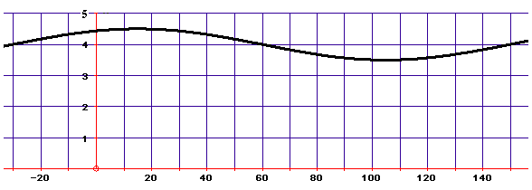

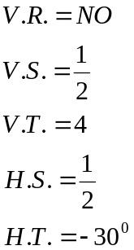

The transformations of y = sinx:

Example 4: For the following graph, list the transformations of y = sinx.

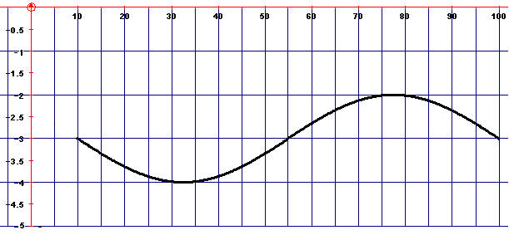

The transformations of y = sinx:
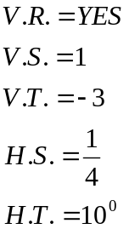

Exercises:

1. For each of the following equations, list the transformations of y = sinx and sketch the
graph.

a) 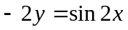 b) 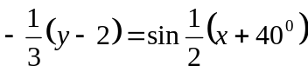

c) 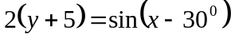 d) 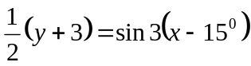

2. For each of the following graphs, list the transformations of y = sinx.

a)
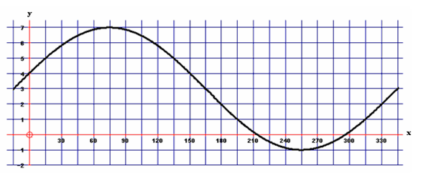

b)
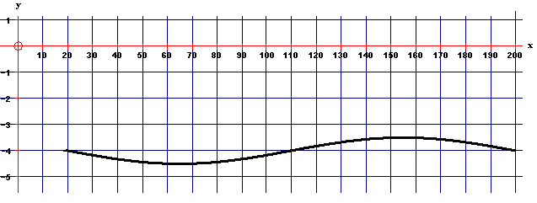

c)
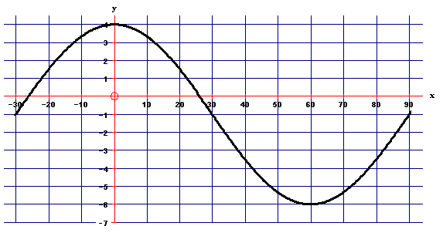

d)
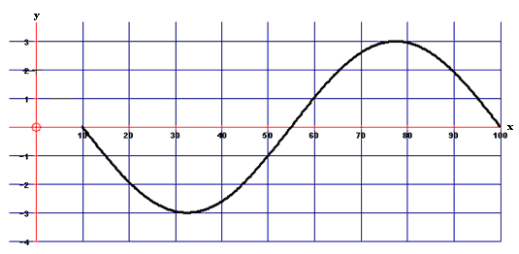

Solutions:

1.a)
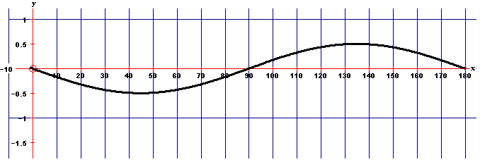

The transformations of y = sinx:
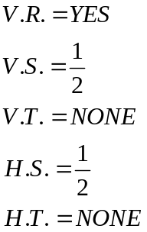

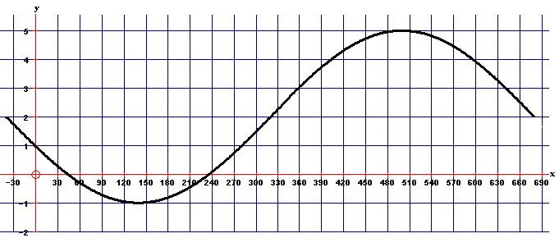
b)

The transformations of y = sinx:
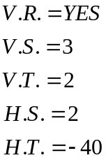

c)
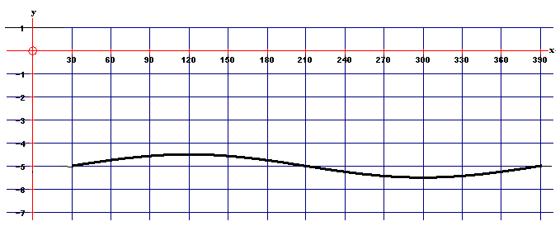

The transformations of y = sinx:
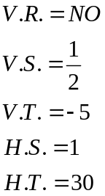

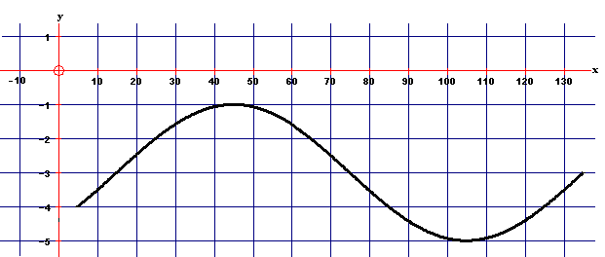
d)

The transformations of y = sinx:
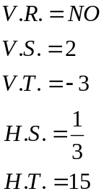

2.
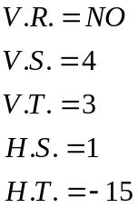

a) The transformations of y = sinx:

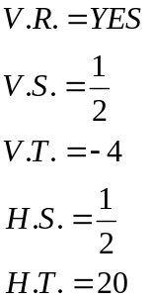

b) The transformations of y = sinx:

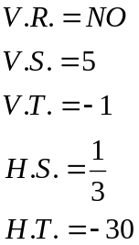

c) The transformations of y = sinx:

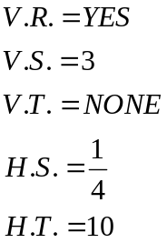

d) The transformations of y = sinx:

Thus far, all the transformations of y = sinx have been determined from the graph. Another way to determine the transformations is from the equation. Recall that the transformational form of y = sinx is If numbers are put into this equation, the transformations can be listed. However, when the transformations are listed there are mathematical concepts that must be applied.

Here is an example that will show those concepts.

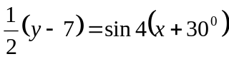
The transformations of y = sinx: There is not a negative sign in front of

This is the denominator of 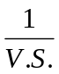and the
reciprocal of

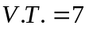 The negative sign will only remain negative
if 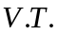is a positive value. The 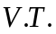is
actually the opposite of what is written
inside the bracket.

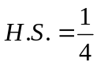The 4 becomes the denominator of 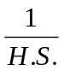.
This is the reciprocal of 4.

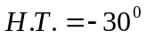The negative sign changes to a positive if
the value of 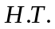is negative. The 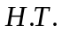is
actually the opposite of what is written
inside the bracket.

The numbers represent the transformations of y = sinx. If there is no number in front of 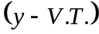 or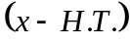, then these transformations should be listed as ONE and not zero.
A rule to follow is list the 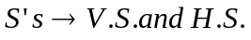 as reciprocals of what appears in the equation and the 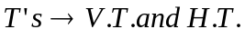 as the opposite of what appears in the equation.
This same rule can be used to write an equation of a sinusoidal curve in transformational form. As you move the listed transformations from a list and into an equation, enter them as reciprocals and opposites.

Example 1: For each of the following equations, list the transformations of y = sinx.
a) 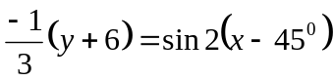 b) 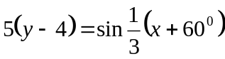
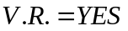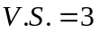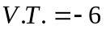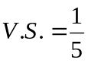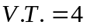
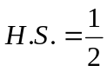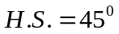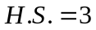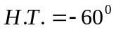

c) 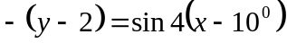 d) 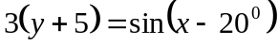

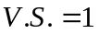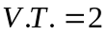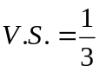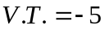
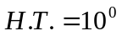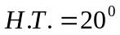

Just as the transformations were listed using the reciprocals and the opposites coming from the equation to the list, the same process is followed going from the list to the equation.

Example 2: For each of the following lists of transformations of y = sinx, write an
equation in transformational form to model each.

a)
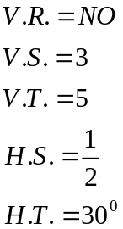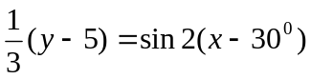

b)
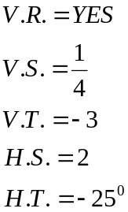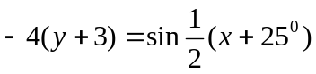

c)

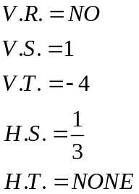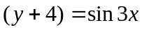

d) 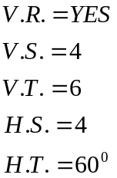 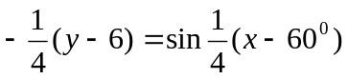

The graph of y = sinx, the transformations of y = sinx, and the equation in transformational form have all been addressed. One more area that must be examined is the mapping rule. A mapping rule explains exactly what happened to the original points of y = sinx when transformations occurred. The mapping rule can be used to create a table of values for the equation. These points can then be plotted to sketch the graph. The same concepts of reciprocals and opposites apply when writing a mapping rule to represent the equation.

Example 3: For each of the following equations, write a mapping rule and create a table
of values:

a) 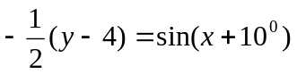 b)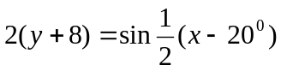 c)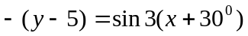

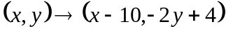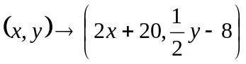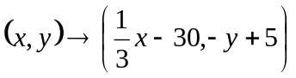

d) 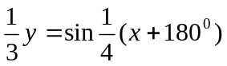

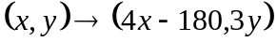

These mapping rules can now be used to create a table of values. List the original values of x and y and then apply the mapping rule to generate the new values.

a)
x (X-10) |  | Y (-2y+4)
0⁰ | -10 | 0 | 4
90⁰ | 80 | 1 | 2
180⁰ | 170 | 0 | 4
270⁰ | 260 | -1 | 6
360⁰ | 350 | 0 | 4

b)
x (2X+20) |  | Y (.5y-8)
0⁰ | 20 | 0 | -8.0
90⁰ | 200 | 1 | -7.5
180⁰ | 380 | 0 | -8.0
270⁰ | 560 | -1 | -8.5
360⁰ | 740 | 0 | -8.0

c)
x (1x-30)  3 |  | Y (-y+5)
0⁰ | -30 | 0 | 5
90⁰ | 0 | 1 | 4
180⁰ | 30 | 0 | 5
270⁰ | 60 | -1 | 6
360⁰ | 90 | 0 | 5

d)
x (4X-180) |  | Y (3y)
0⁰ | -180 | 0 | 0
90⁰ | 180 | 1 | 3
180⁰ | 540 | 0 | 0
270⁰ | 900 | -1 | -3
360⁰ | 1260 | 0 | 0

The points that are in blue are the points that would be plotted to sketch the graph. These points represent the five critical values for the graph of y = sinx that have undergone transformations. Students who have difficulty sketching the graph by applying the transformations to y = sinx use this method to create the graph. Graphing was initially introduced to students as plotting points and many are still more proficient at this method than any other. The end result is the same – the graph of the sinusoidal curve.

The next sinusoidal curve to explore is that of y = cosx.

The table of values for y = cosx is:

X | 0⁰ | 90⁰ | 180⁰ | 270⁰ | 360⁰
Y | 1 | 0 | -1 | 0 | 1

Notice that the y-values of the five critical points are different than those of y = sinx.

The graph of y = cosx:

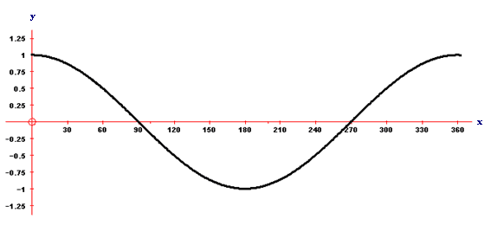

The parts of the curve, the transformations of y = cosx, writing a mapping rule and creating a table of values are all done in the same format as those of y = sinx.

Example 4:

For each of the following equations, write a mapping rule, create a table of values and sketch the graph.
Note: These are the same equations used in Example 3 with the function being the only
change.

a) 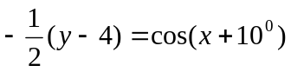 b)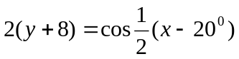 c)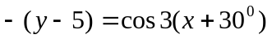

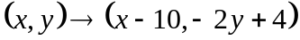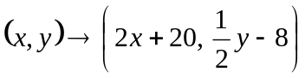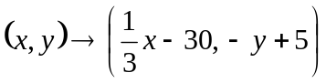

d) 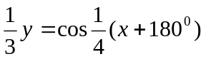

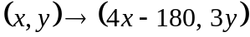

These mapping rules can now be used to create a table of values. List the original values of x and y and then apply the mapping rule to generate the new values. The x-values are the same for both y = sinx and y = cosx. Notice that the y-values are different.

a)
x (X-10) |  | Y (-2y+4)
0⁰ | -10 | 1 | 2
90⁰ | 80 | 0 | 4
180⁰ | 170 | -1 | 6
270⁰ | 260 | 0 | 4
360⁰ | 350 | 1 | 2

b)
x (2X+20) |  | Y (.5y-8)
0⁰ | 20 | 1 | -7.5
90⁰ | 200 | 0 | -8.0
180⁰ | 380 | -1 | -8.5
270⁰ | 560 | 0 | -8.0
360⁰ | 740 | 1 | -7.5

c)
x (1x-30)  3 |  | Y (-y+5)
0⁰ | -30 | 1 | 4
90⁰ | 0 | 0 | 5
180⁰ | 30 | -1 | 6
270⁰ | 60 | 0 | 5
360⁰ | 90 | 1 | 4

d)
x (4X-180) |  | Y (3y)
0⁰ | -180 | 1 | 3
90⁰ | 180 | 0 | 0
180⁰ | 540 | -1 | -3
270⁰ | 900 | 0 | 0
360⁰ | 1260 | 1 | 3

a)

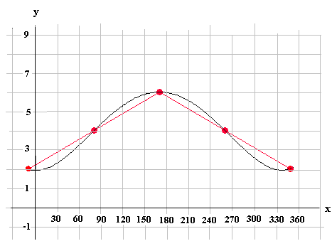

b)

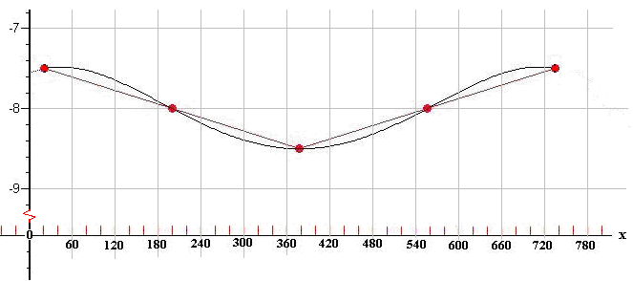

c)

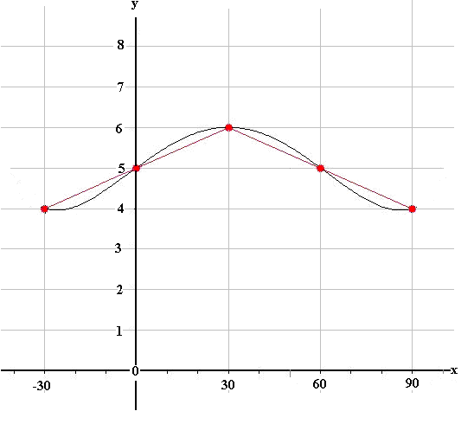

d)



